ShopEZ: Data Flow & User Stories

**Project Design Phase-II**

**Data Flow Diagram & User Stories**

|  |  |
| --- | --- |
| Date | 28-06-2025 |
| Team ID | LTVIP2025TMID55672 |
| Project Name | ShopEZ: One-Stop Shop for Online Purchases |
| Maximum Marks | 4 Marks |

# Data Flow Description

The system consists of modules for user interaction, product management, order handling, and administrative control.

Data flows between frontend, backend API, and MongoDB.

Example:

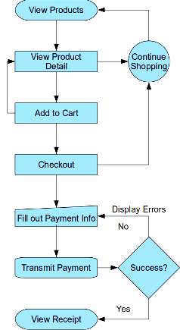

# User Stories

As a user, I can register and log in.

As a user, I can browse and filter products.

As a user, I can add items to the cart and checkout.

As an admin, I can add, update, and remove products.

As an admin, I can view and manage orders.